Company Name  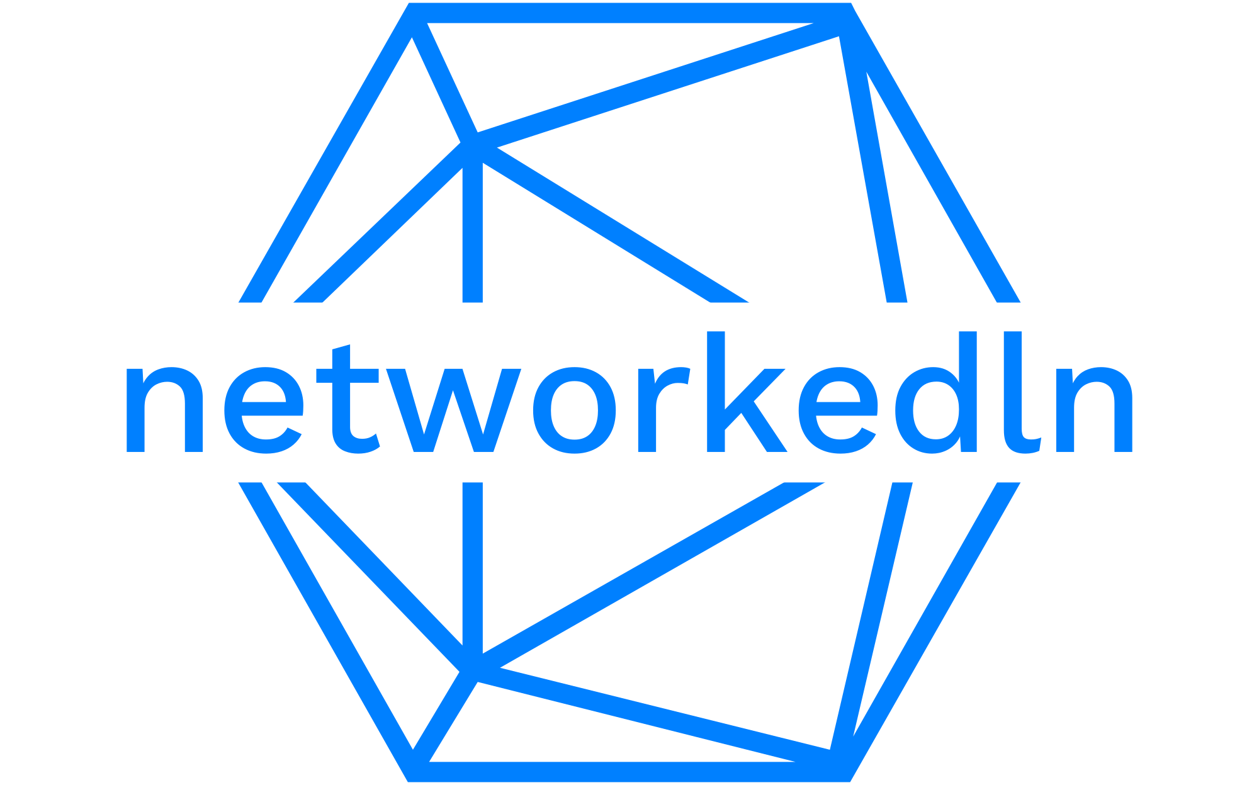 | invoice
+961 70596440 | www.networkedln.com | INVOICE # 20230731  DATE 2023/07/31
TO
MOMBURGER
Mar Mikhael
Description | Amount
System Maintenance – Site Visit | 40$
Total | 40$

Thank you for your business!

